**Color Scheme Study:**

* Number of colors:
  + Most people remember things that are in seven segments or less. We want this to be easy to use and not overwhelming, so we need to stay under 7
  + In a study of 50 peers…
    - 75% of people we asked said more than 7 colors would be too overwhelming
    - 54% of people we asked agreed that we need more than 4 colors—4 or less isn’t specific enough for highly syntactic languages like C++
* Inspiration syntax highlighter color schemes:
  + What worked: Palettes with colors that weren’t too close to each other
  + What didn’t work: Monochromatic palettes (colors were hard to discern when font was small or far away)
  + In a study of 50 peers…
    - 11 (22%) liked Arduino Light the best
    - 8 (16%) liked Xt 256
    - 3 (6%) liked Mono the best
    - 12 (24%) liked Default the best
    - 5 (10%) liked Dark the best
    - 11 (22%) liked Doco the best
  + Conclusion: 5-7 colors, lots of variation, bright colors that pop
* Other factors affecting our decision:
  + Pre-established iMessage colors: bright green, bright blue
    - Greys, blacks, and creams in keyboard and message backgrounds
    - Apple apps that pop up in the message bar
    - Pastel group message backgrounds
  + Originality: Can’t use a syntax highlighting scheme that’s already been done
  + iPhone “Mode”: we are matching it to light mode (so light background), but will make a dark mode scheme down the road
* Final color palette:
  + **Background Color:** #F6F6F6
  + **Regular Text Color:** #1E1E1F
  + **Comments Color:** #CACCD2
  + **Color-Coding Colors:** #EA428F, #E9402F, #DFFD52, #AEFA4E, #74FBAF, #66DDEF

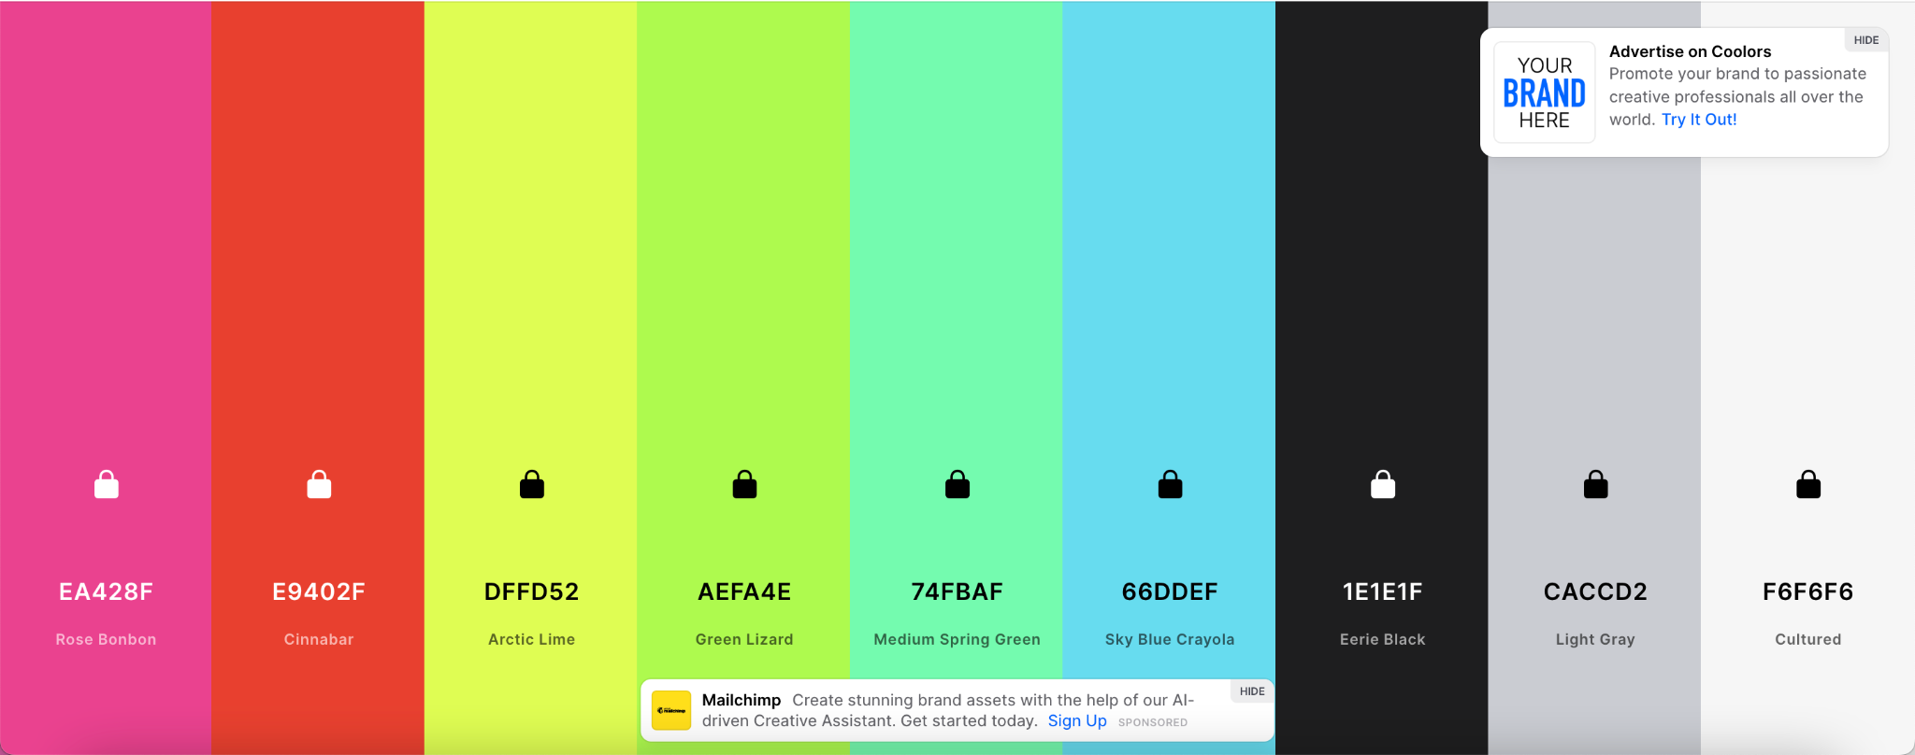

* Sources:
  + <https://developer.apple.com/design/human-interface-guidelines/foundations/color/>
  + <https://psycnet.apa.org/record/1957-02914-001>
  + <https://www.vectornator.io/blog/monochromatic-colors/#:~:text=However%2C%20it's%20not%20as%20simple,the%20base%20color%20or%20hue>
  + <https://forums.macrumors.com/threads/apple-blatantly-rips-off-the-design-and-color-palette-of-their-activity-app.1859550/>
  + <https://www.patentlyapple.com/2016/06/apples-activity-app-icon-is-now-a-registered-trademark.html>
  + <https://www.iosicongallery.com/icons/activity-2017-09-26/>